

Game Design Document

Made by Jose Carlos Gomez

Project Description. . . . . . . . . . . . . . . . . . . . . . . . . . . . . . . . . . . . . . . . . . . . . . . . . . . . . . . . . . . . 1

Synopsis . . . . . . . . . . . . . . . . . . . . . . . . . . . . . . . . . . . . . . . . . . . . . . . . . . . . . . . . . . . . . . . . . . . 2

Game Overview . . . . . . . . . . . . . . . . . . . . . . . . . . . . . . . . . . . . . . . . . . . . . . . . . . . . . . . . . . . . . 2

Game Objectives . . . . . . . . . . . . . . . . . . . . . . . . . . . . . . . . . . . . . . . . . . . . . . . . . . . . . . . . . . . . 2

Platform Minimum Requirements . . . . . . . . . . . . . . . . . . . . . . . . . . . . . . . . . . . . . . . . . . . . . . . . 2

Unique Selling Points . . . . . . . . . . . . . . . . . . . . . . . . . . . . . . . . . . . . . . . . . . . . . . . . . . . . . . . . . 2

Game Structure . . . . . . . . . . . . . . . . . . . . . . . . . . . . . . . . . . . . . . . . . . . . . . . . . . . . . . . . . . . . . 2

Game Camera . . . . . . . . . . . . . . . . . . . . . . . . . . . . . . . . . . . . . . . . . . . . . . . . . . . . . . . . . . . . . . 3

Game Controls . . . . . . . . . . . . . . . . . . . . . . . . . . . . . . . . . . . . . . . . . . . . . . . . . . . . . . . . . . . . . . 3

HUD . . . . . . . . . . . . . . . . . . . . . . . . . . . . . . . . . . . . . . . . . . . . . . . . . . . . . . . . . . . . . . . . . . . . . . 3

Players . . . . . . . . . . . . . . . . . . . . . . . . . . . . . . . . . . . . . . . . . . . . . . . . . . . . . . . . . . . . . . . . . . . . 4

Citations for Assets . . . . . . . . . . . . . . . . . . . . . . . . . . . . . . . . . . . . . . . . . . . . . . . . . . . . . . . . . . . 4

Project Description:

This game is a 2D arena shooter made to help me better understand the unity engine. The game has the user playing as a sniper that has a goal to shoot gold blocks by shooting off walls in order for the bullets to get to their desired target.

The game currently has only 3 levels, but has been made to easily create more. The game also has room for expansion and the ability to create new mechanics. Since I do have a short deadline, only the basics have been implemented.

Synopsis:

In a world full of red targets, one man must overcome them to become the best trick shot shooter this world has ever seen. Play as Lt Steevan Cost to shoot all of the red targets to get through all 3 levels.

Game Overview:

Title: 2D Trick Shot

Platform: PC Standalone

Genre: 2D Arena Shooter

Rating: (E) for everyone

Target: Casual gamer (aging from 12 - 30)

Release date: November, 2018

Publisher: Jose Carlos Gomez

2D Trick Shot is an arena shooter where the player must use walls to navigate their bullet to the targets. Shoot all of the objects and then game is done.

Game Objectives:

Shoot your bullets and have them bounce off walls to hit your target. There are 3 levels, each a bit tougher than the last.

Platform Requirements

PC, MAC AND LINUX STANDALONE OS: Windows XP SP2+, Mac OS X 10.8+, Ubuntu 12.04+, SteamOS+

Graphics card: DX9 (shader model 2.0) capabilities; generally everything made since 2004 should work

Unique Selling Points

Want to shoot some wickedly cool trick shots to hit targets like no other has done before? Now you can with the help of Unity’s awesome 2D physics.

Game Structure

Main Menu → Play Game and beat levels → Main Menu

There are also options on the main menu to view credits or quit the application

Game Camera:

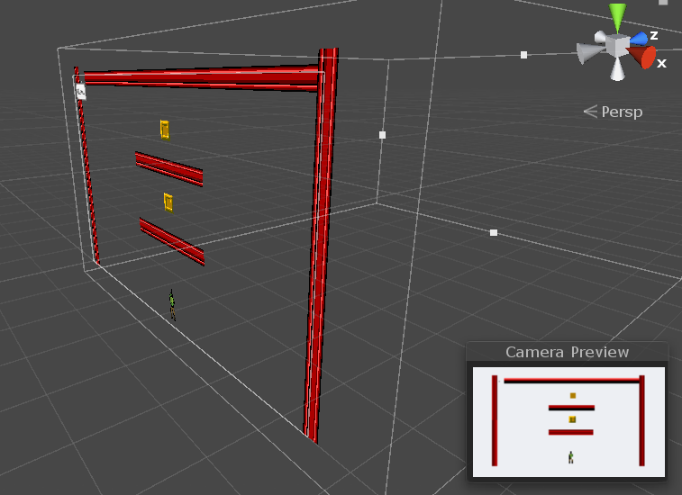  
The main camera stays a fixed distance away from the game setting. Making it easy to see the entire map as well as all of the targets in it.

Game Controls:  
Movement: A & D keys or the left and right Arrow Keys to rotate in the world; Steevan Cost reacts to those rotations. A & D and the Arrow Keys are bound to strict axises so will not turn more than 80 degrees in each direction.

HUD:  
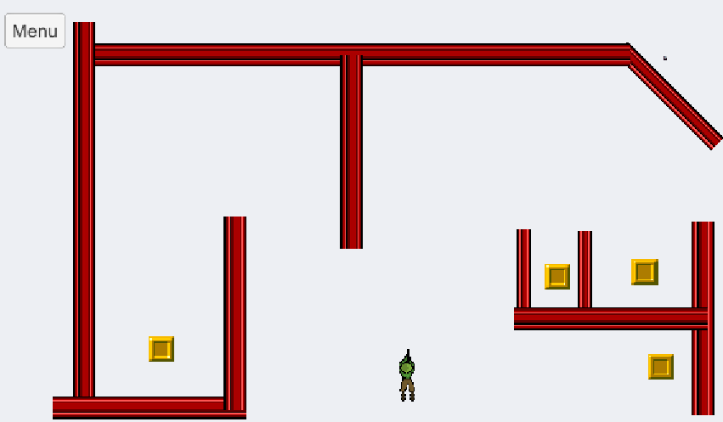

On the upper-right corner, there is an exit button that can be used to return to main menu

Players:

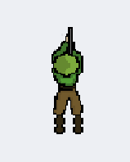

Steevan Cost is a Lt marine who had his life turned upside down when targets began appearing all over the world and out of reach of people to shoot. Steevan, an aspiring Computer Scientist, took it upon himself to clear the world of these mildly threatening targets for the sake of our peace of mind, I guess.

Citations for Assets:

For Assets I downloaded from the Unity Store:

SUPER ICON LTD - Free 8-Bit Pixel Pack

POSH TOFFEE GAMES - Shooter Sprite Pack